**Project Title: Employment Trends in Africa regions**

**Introduction**

Employment trends are a critical aspect of understanding the socio-economic landscape of any region. This project delves into a comprehensive analysis of employment rates in various African regions, with a focus on the years 2005, 2010, 2015, and 2021. The aim is to provide valuable insights for policymakers, businesses, and researchers by examining how employment rates have evolved over time, understanding disparities, and identifying the influence of industries and regions.

**Scope of the project**

The ultimate goal of the project is to analyze the dataset in order to find valuable insights for policymakers, businesses, and researches by examining how employment rates have evolved over time, understanding disparities, and identifying the influence of industries and regions.

**Dataset**

The dataset contains information about employment rates in various African regions, categorized by industry, gender, and year. It appears to have five features: Region, Year, Category (industry), Gender, and Employment rate (%). This data enables analysis of employment trends across different regions and demographic factors.

**Attribute Information**

- Region: The geographical region within Africa where the employment data was collected. This feature specifies the location context for the employment rates.

- Year: The year in which the employment data was recorded. This temporal attribute allows for time-based analysis to identify trends and changes over different years.

- Category: The category of industry to which the employment data corresponds. It includes sectors such as Agriculture, Industry, and Services, providing insights into employment distribution across different sectors.

- Gender: The gender classification, indicating whether the employment data is specific to males, females, or both (Male and Female). This feature allows for gender-based analysis of employment rates.

- Employment rate (%): The percentage value representing the employment rate for the specified region, year, industry category, and gender. This numeric attribute quantifies the level of employment within the given context.

**Data preparation and validation**

- Data collection: World Bank Database

- Data Cleaning and manipulation: Excel

- Analysis tools: Rstudio

**Exploratory Data Analysis (EDA):**

Conduct exploratory data analysis to gain a preliminary understanding of the dataset.

Create summary statistics, data visualizations, and descriptive reports.

Identify trends, patterns, and potential areas of interest.

Let's now load R packages and dataset. As we can see above, the variables:

- Region

- Year

- Category

- Gender

- Employment rate (%)

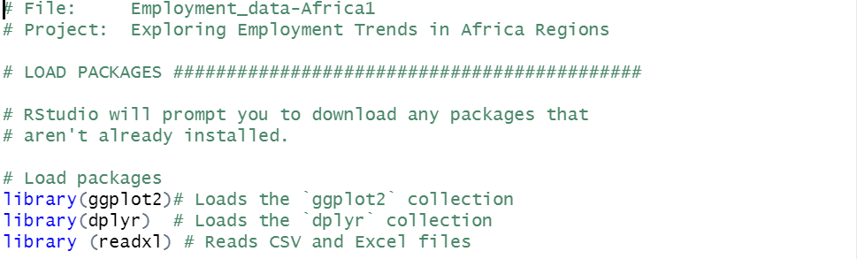

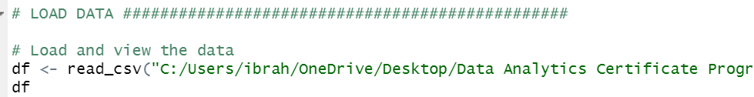

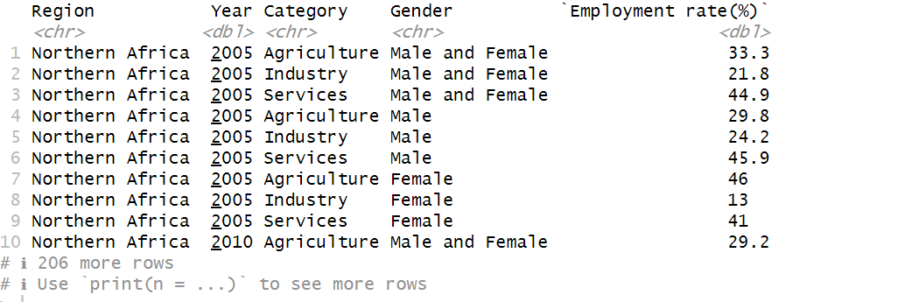

**Summary of Statistics Models (Mean, Median, Standard Deviation, percentiles for different regions, years, and categories.)**

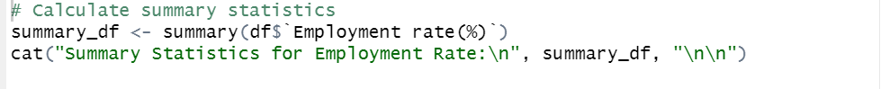



The output shows key summary statistics, including the minimum, 1st quartile (Q1), median, mean, 3rd quartile (Q3), and maximum values.

Here's an interpretation of the summary statistics:

Minimum: 4.5

1st Quartile (Q1): 14.225

Median: 30

Mean: 33.33565

3rd Quartile (Q3): 49.725

Maximum: 75.7

Interpretation:

The "Minimum" value of 4.5 is the lowest employment rate observed in the dataset.

The "1st Quartile" (Q1) value of 14.225 represents the 25th percentile, meaning 25% of the data falls below this value.

The "Median" value of 30 is the middle value of the dataset when it's sorted in ascending order. It's also known as the 50th percentile.

The "Mean" value of 33.33565 is the average employment rate for the dataset.

The "3rd Quartile" (Q3) value of 49.725 represents the 75th percentile, meaning 75% of the data falls below this value.

The "Maximum" value of 75.7 is the highest employment rate observed in the dataset.

These summary statistics provide a snapshot of the distribution of employment rates in the dataset. You can use this information to understand the central tendency, variability, and range of the data. It's important to consider these statistics in the context of your analysis and research questions.

**Times series analysis**

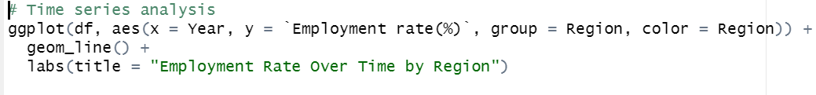

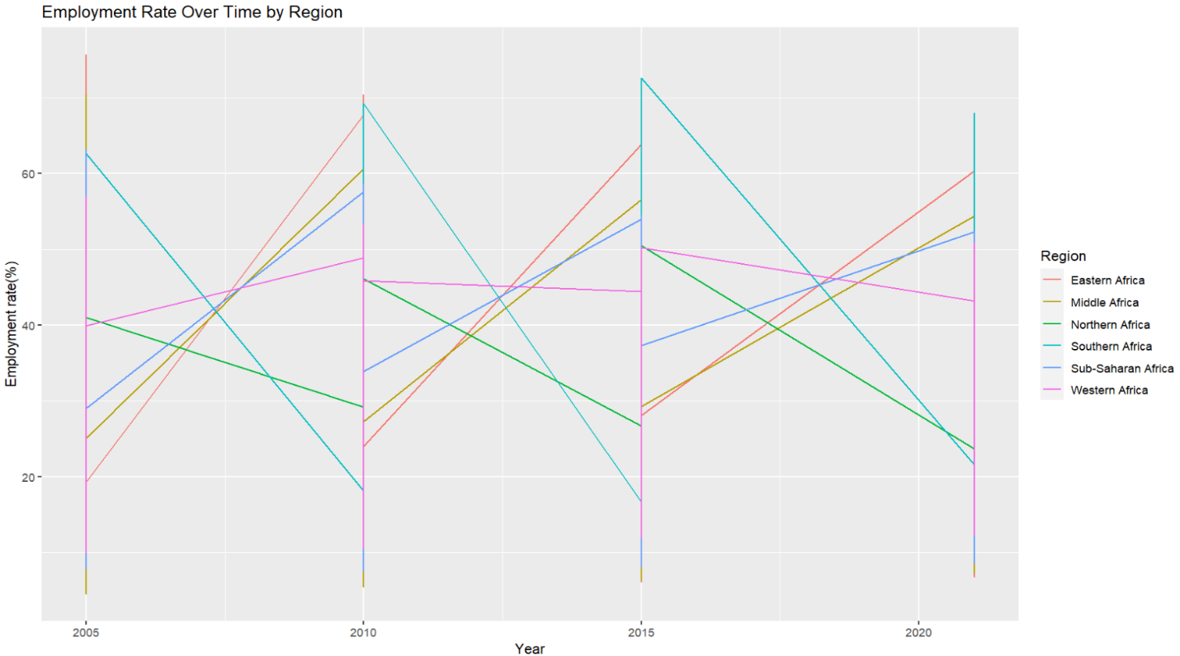

Time Series Analysis shows how the employment rate has changed over time in each region.

**Gender-Based Analysis**

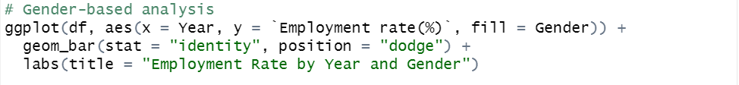

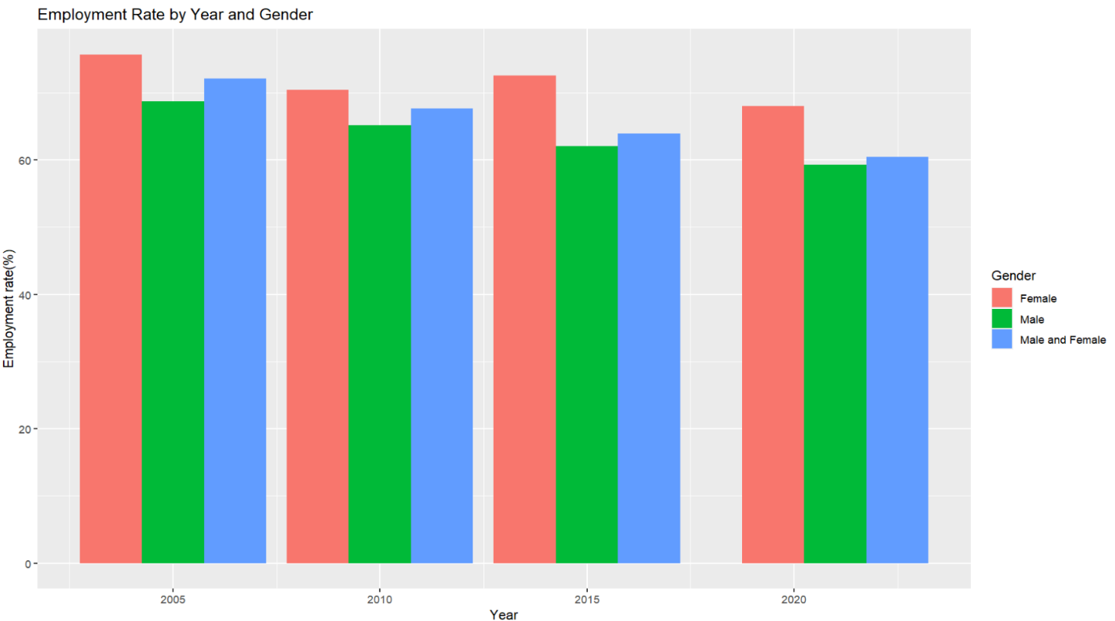

Gender-Based Analysis compare employment rates between males and females within each region and category.

**Categorical Analysis**

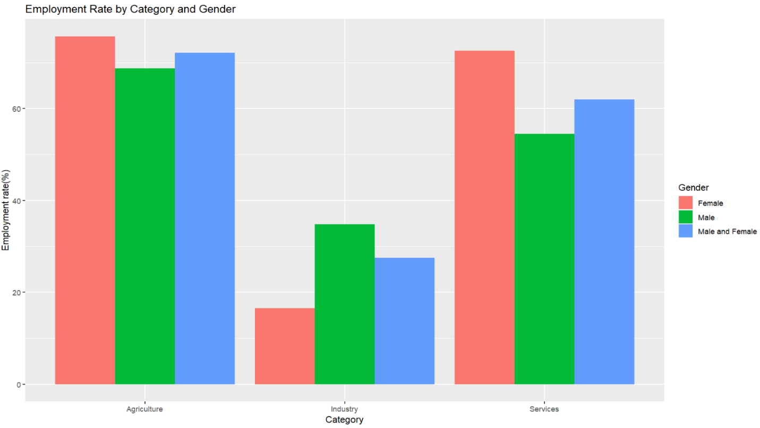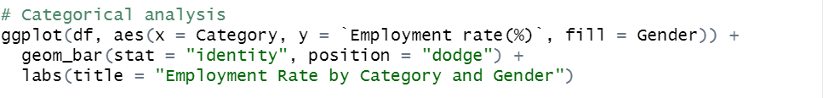

Categorical Analysis explore the differences in employment rates across different categories

Categorical Analysis explore the differences in employment rates across different categories (Agriculture, Industry, Services) within each region and gender.

**Regional Comparison**



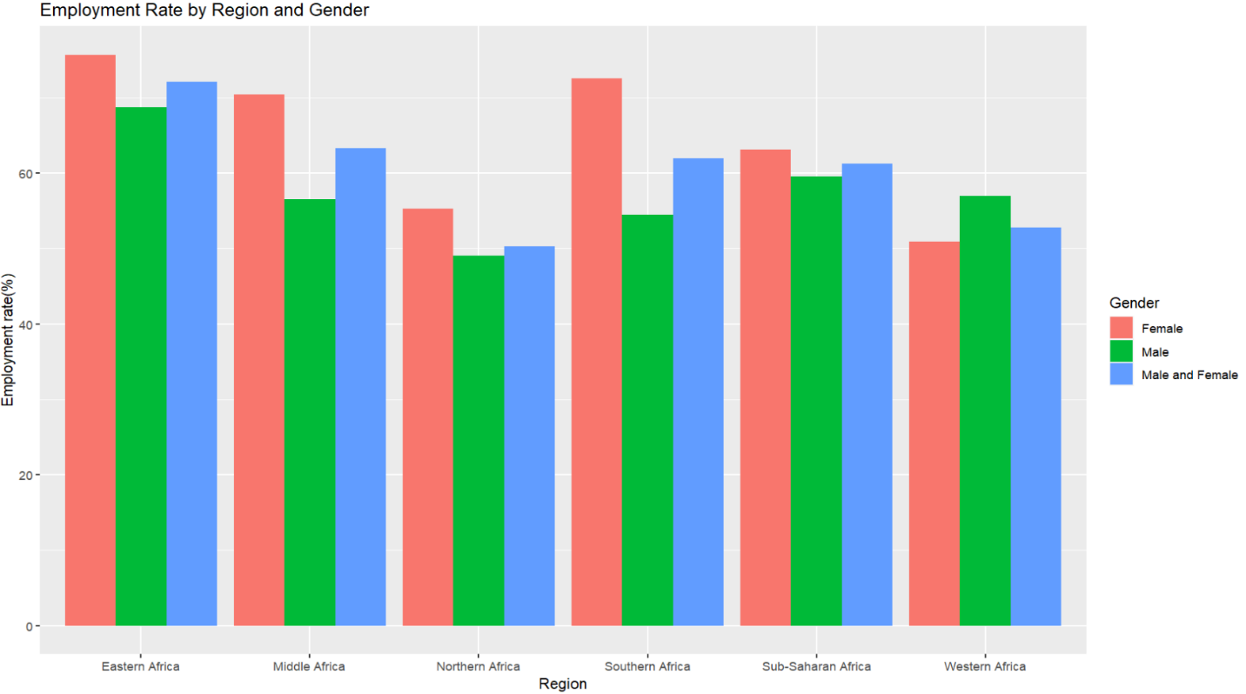

Regional Comparison compare employment rates between different regions using bar charts or box plots.

**Correlation Analysis**

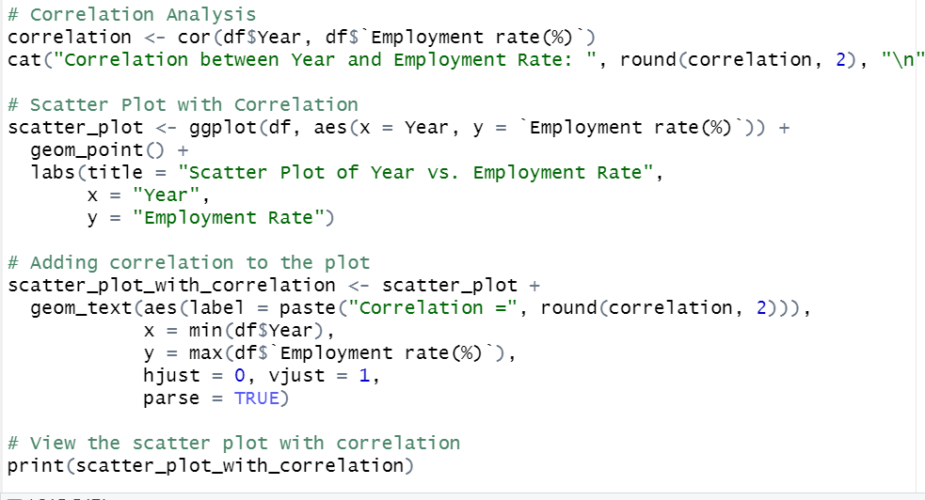

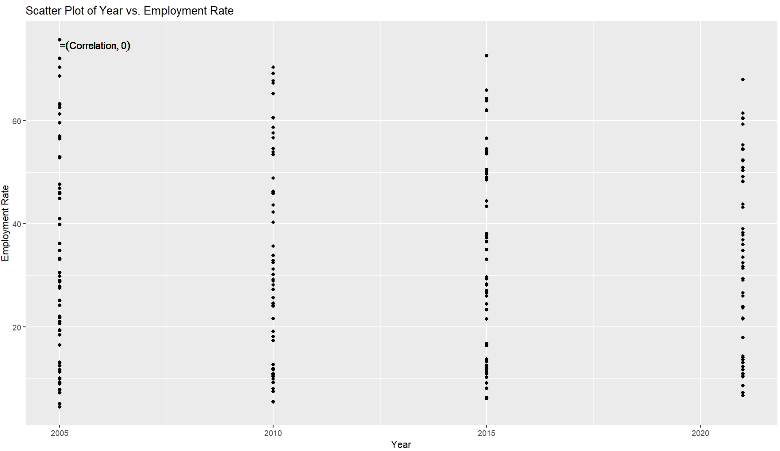

Correlation Analysis checks a correlation between years and employment rates.

**Heatmaps Analysis**

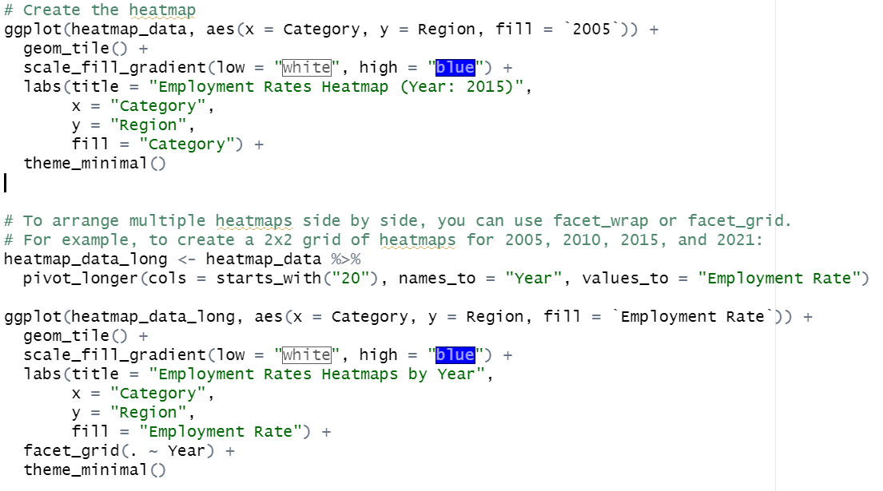

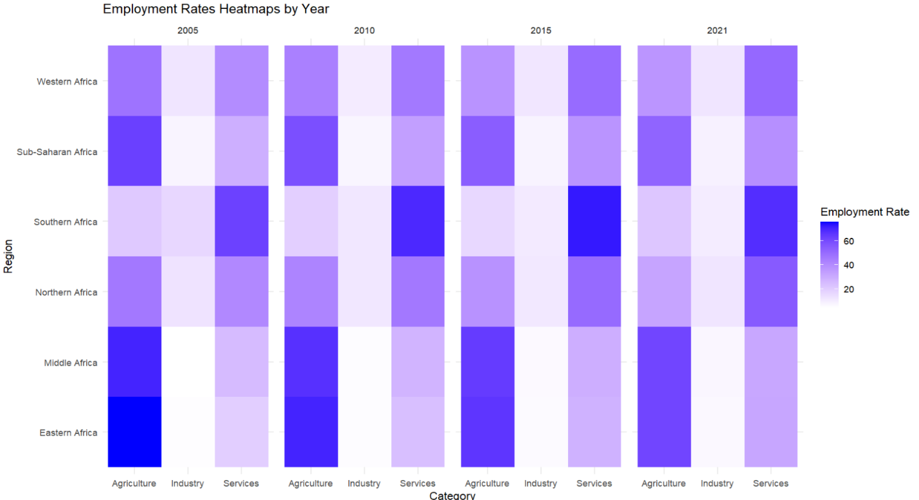

Heatmaps allows to visualize employment rates across regions, years, and categories. Heatmaps can provide a quick overview of the data.

**Economic disparities Analysis**



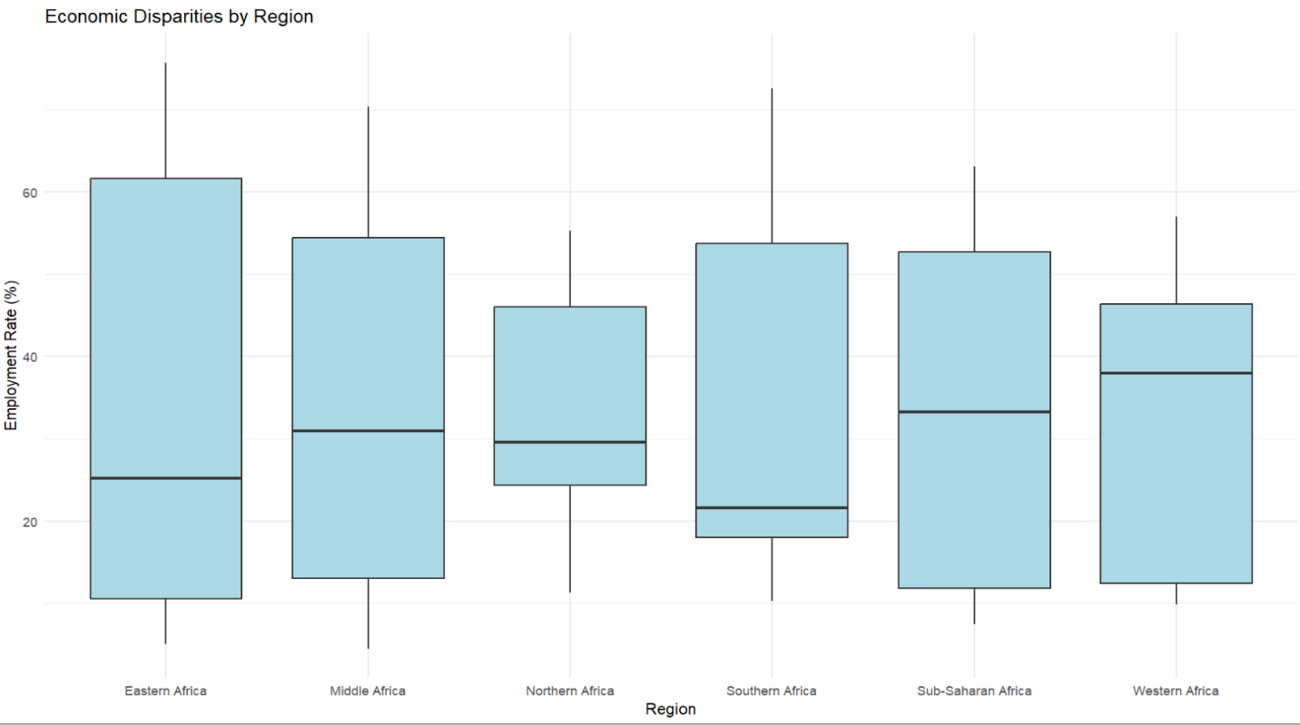

Economic disparities analysis shows the distribution of employment rates across different regions in terms of economic growth.

**One-way analysis of variance (ANOVA)**

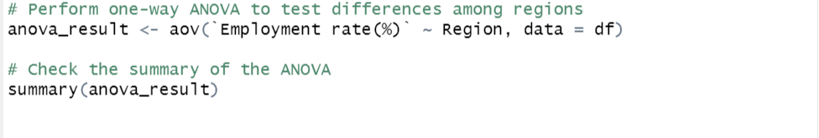

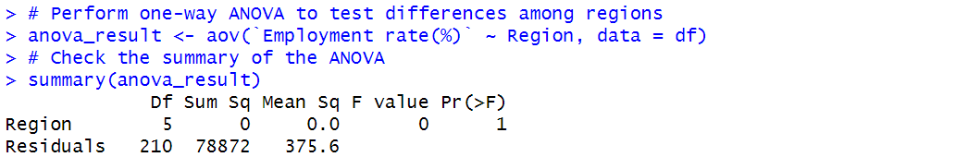

A one-way analysis of variance (ANOVA) to test for differences among regions in terms of the "Employment rate(%)" variable. Here's an interpretation of the ANOVA results:

ANOVA Table:

Df (Degrees of Freedom): There are two components in the ANOVA table. The "Region" factor has 5 levels, and the "Residuals" represent the unexplained variance with 210 degrees of freedom.

Sum Sq (Sum of Squares): The sum of squares for the "Region" factor is 0, indicating that there is no significant variation explained by the region factor. In contrast, the "Residuals" sum of squares is 78872, representing the unexplained variation in the data.

Mean Sq (Mean Square):

The mean square for the "Region" factor is 0.0, and for the "Residuals" is 375.6.

F value:

The F-statistic is used to test whether there are significant differences among the group means. In this case, the F value for the "Region" factor is 0, which means that there is no significant difference in employment rates among the regions.

Pr(>F) (p-value):

The p-value associated with the F-statistic is 1. A p-value of 1 indicates that there is no evidence to reject the null hypothesis, suggesting that there are no significant differences among the regions in terms of employment rates.

Interpretation:

Based on the ANOVA results, there is no statistically significant difference in employment rates among the regions included in the analysis. The p-value is 1, which is much greater than the typical significance level (e.g., 0.05), indicating that there is no evidence to conclude that the means of the "Employment rate(%)" vary significantly across regions.

**Key Findings and Recommendations:**

Key Finding 1: Regional Employment Disparities

The analysis reveals significant regional disparities in employment rates. For instance, in Northern Africa, employment rates have generally been lower compared to Sub-Saharan Africa. This regional disparity has been consistent across the years, with Northern Africa showing lower employment rates overall.

Recommendation 1: Regional Economic Policies

Regional governments should consider implementing targeted economic policies to stimulate employment growth in regions with consistently low rates.

Initiatives such as job training programs, incentives for new businesses, and investment in key industries can help address these disparities.

Key Finding 2: Gender-Based Disparities

Gender disparities in employment rates are evident. Across regions and employment categories, males consistently have higher employment rates compared to females. For example, in Northern Africa, males consistently have higher employment rates in all categories over the years.

Recommendation 2: Gender Equality Initiatives

Policies promoting gender equality in the workforce, such as equal pay for equal work and flexible working arrangements, should be considered.

Targeted programs to empower women in the labor market, such as vocational training and education initiatives, could help bridge the gender gap.

Key Finding 3: Time Series Analysis

Over time, there are fluctuations in employment rates, but trends differ by region and category. In Northern Africa, employment rates show a declining trend, particularly in the Industry category. Conversely, Sub-Saharan Africa shows an increasing trend in employment rates across all categories.

Recommendation 3: Adaptation to Changing Economic Conditions

Governments should adapt to changing economic conditions by diversifying their economies and investing in sectors with growth potential.

Monitoring and responding to these trends is essential to ensure that labor markets remain robust and that employment rates are sustained.

Key Finding 4: Economic Disparities

Economic disparities between regions are a major factor in employment rates. Regions with stronger economies tend to have higher employment rates. For instance, in Southern Africa, where the services sector is dominant, employment rates are higher.

Recommendation 4: Economic Development Strategies

Governments should focus on economic development strategies that enhance the overall economic well-being of regions. This may involve promoting investment, industrialization, and diversification in regions with lower employment rates.